Course Name and Course Code: Advance Programming (3CS362)

Project Title: Scheduler Pro

Project Team: Name and Roll No

Shridhar Sambhaji Patil 2017BTECS00040

Aniket Rajesh Modak 2017BTECS00068

Neha Ravikant Jawanjal 2018BTECS00211

Harshraj Gunwant Dhote 2018BTECS00212

Idea:

The main idea is to create a Personal Scheduler to maintain the day to day list of task, following are uses of our project:

1) Maintaining tasks to do

2) Update and delete tasks

Flowchart:

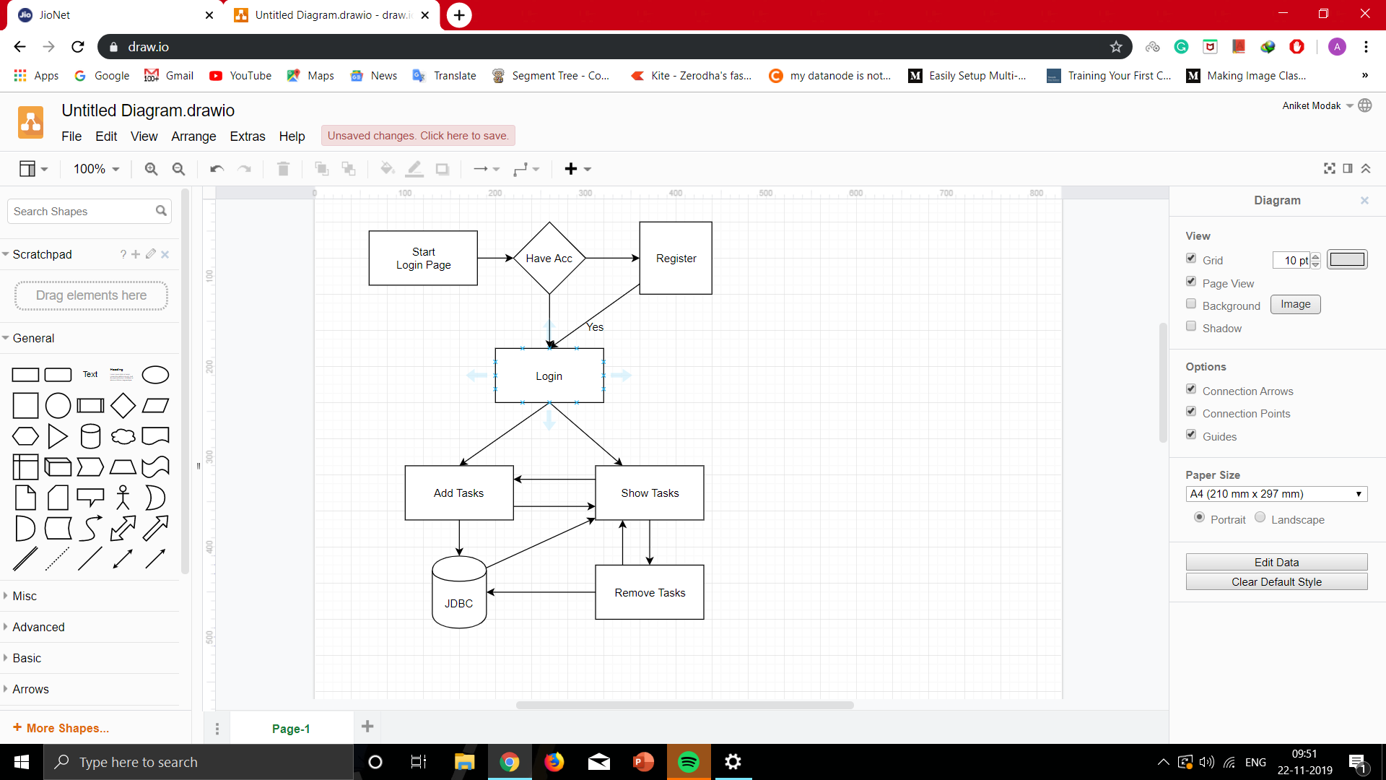

Screenshots:

Login screen where user can login and if he/she doesn’t have the Account he/she can create Account by clicking on the signup button.

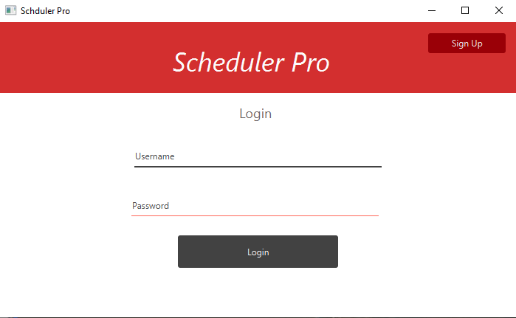

Signup screen let the user to sign up into the system

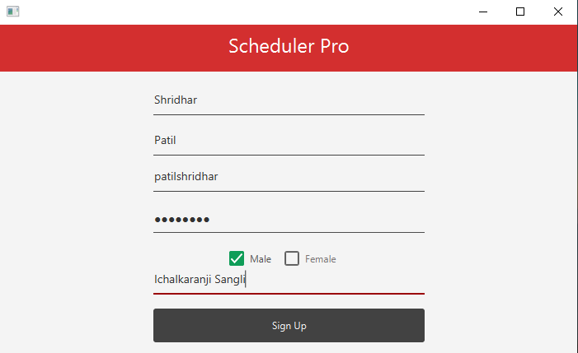

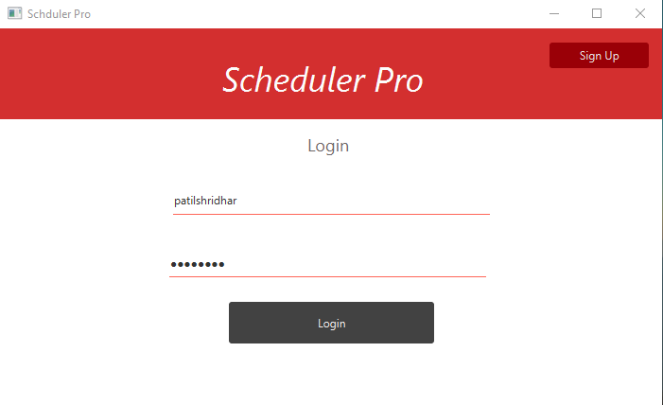

Current Tasks

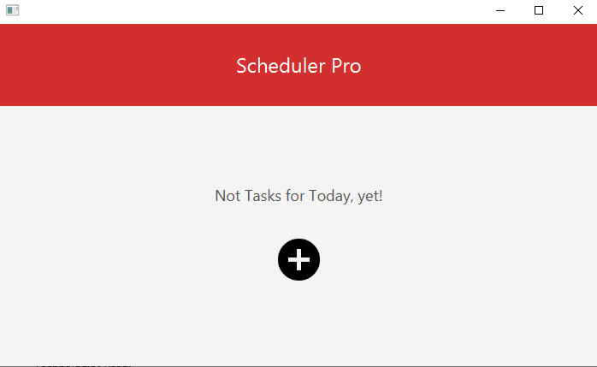

Add Task Window

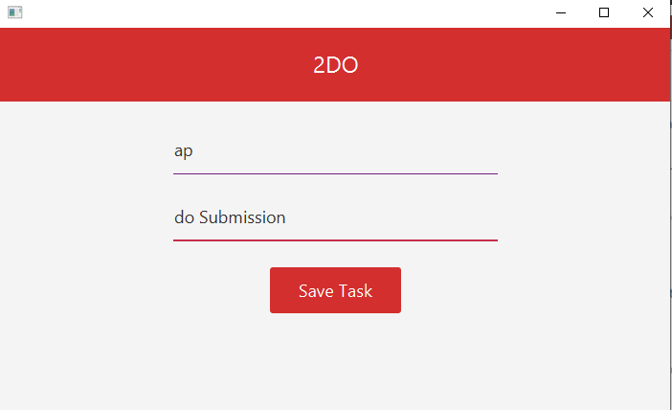

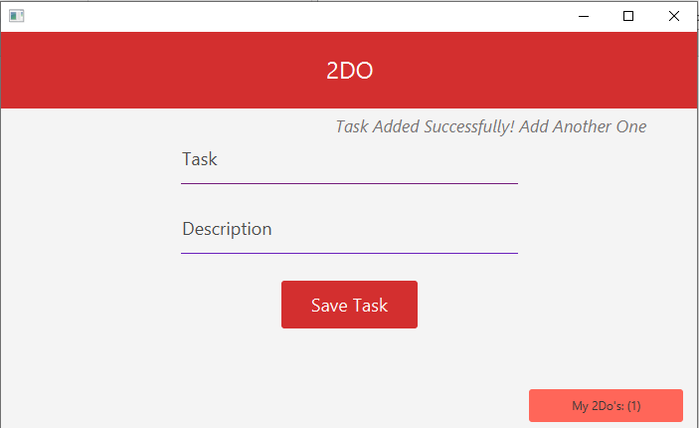

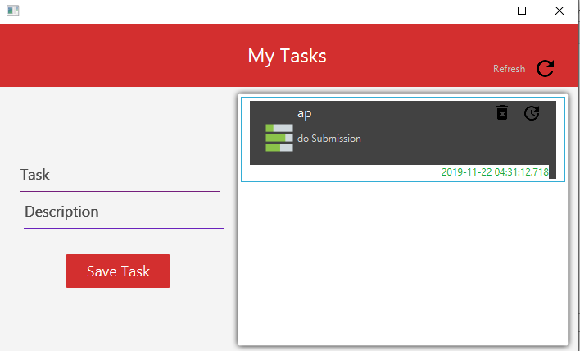

Update task Screen

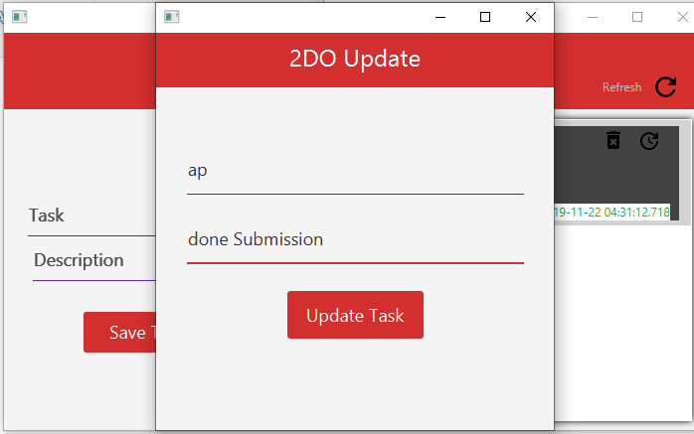

Database schema:

users(userid,firstname,lastname,username,password,location,gender)

tasks(taskid,userid,datecreated,description,task)

Technologies used:

Front end- JavaFX, JFeonix

Backend- Mysql

Conclusion:

This application would help to main the list of tasks that user want to perform in future.